**Best European Powerlifters of the year 2019.**  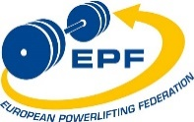

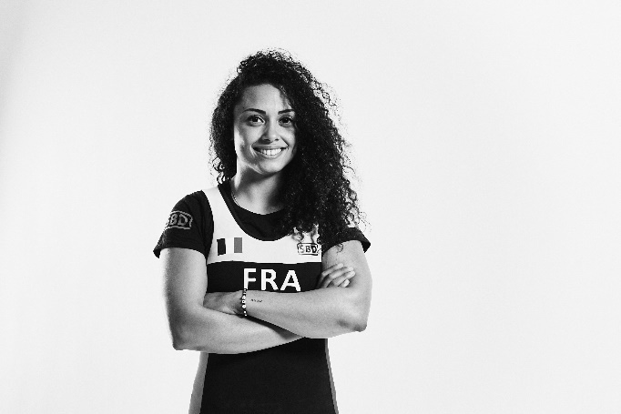

***Prescilla Bavoil***, France.

Best European Powerlifter of 2019 in Classic.

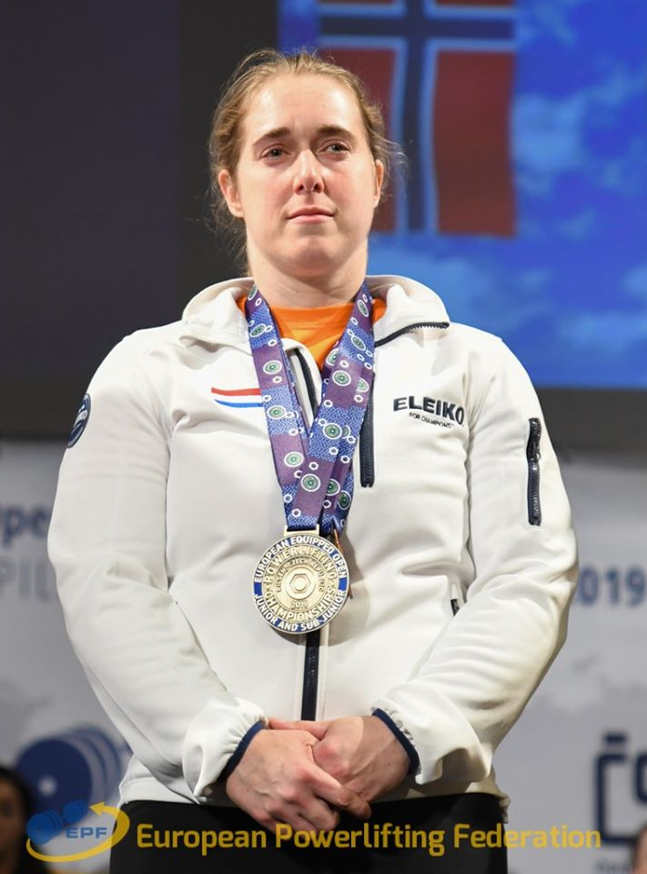

***Ankie Timmers,*** Netherland.  
Best European Powerlifter of 2019 in Equipped .

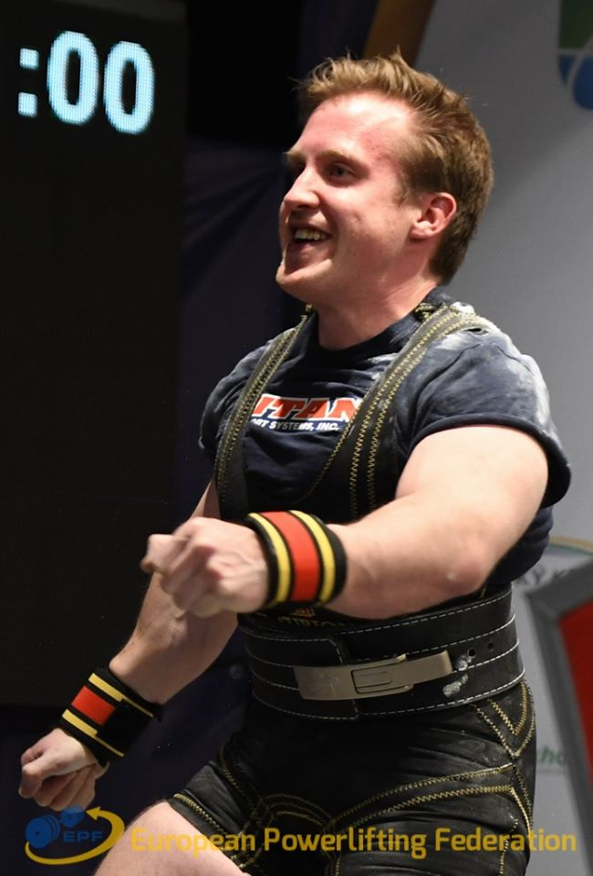

***Kjell Bakkelund***, Norway.   
Best European Powerlifter of 2019 in Equipped.

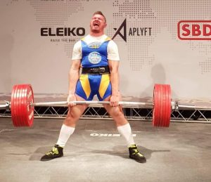

***Anatolii Novopismennyi***, Ukranie.

Best European Powerlifter of 2019 in Classic.