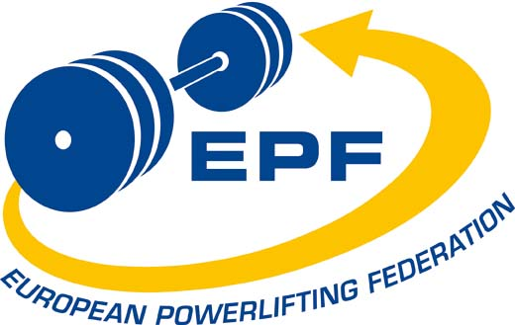

EPF PROMOTER’S CONTRACT

Article 1 – General

1.1 Contract
This contract is between the European Powerlifting Federation (the EPF), being the incorporated association with organization number 982 755 867 in Bronnoysundregistrene, Norway.
And

The

Who is a full member national affiliate federation of EPF and agrees to fully comply with the terms and conditions stated in this Contract?
In this Contract the term “Promoter” shall mean the national EPF member federation as well as the term “the parties” shall mean the EPF and the Promoter.
If the full membership of the Promoter lapses, is ceased or is suspended, this Contract automatically deemed to be voided and ceased.

This Contract will be governed by the laws of Norway and in additions, the parties of this Contract shall retain all rights and obligations according to the EPF Constitution and By-laws.

The Promoter, by virtue of this Contract, undertakes to conduct the Championship, referred to in item 1.3, in accordance with the IPF Technical Rules, IPF Antidoping rules, the EPF Constitution and By Laws and in substantial compliance with each item of the EPF Organizer’s Checklist. The EPF sanctions the Championship and agrees to not establish any other events of the same title and nature for that Calendar year.
This Contract is to be signed as accepted by the Promoter and the EPF within 2 years of the confirmed awarding of the event or latest 30 days after the date the Promoter has received the contract from EPF.

1.2 Delegation
Only a national affiliate of the EPF may apply for and be awarded a sanction.
The Promoter (i.e., the awarded national federation) may assign the sanction for the event but it shall remain fully liable for the performance of this contract. Such assignation may only be made to an individual or entity after notification to the EPF of the identity of that assignee and after the EPF gives approval of the assignee. Only individuals or entities in good standing with the EPF may act as assignees within this contract. Any promoter assigning this contract shall obtain written acknowledgement from the assignee that the assignee is equally bound by the terms and conditions of this contract. The assignation can only be made with the approval of the EPF.

The EPF shall be entitled to proceed against the Promoter as well as the Assignee, which shall be jointly and severally liable.
The Promoter or the Assignee cannot incur debts on behalf of the EPF, nor bind the EPF in any further contracts, without the EPF’s written agreement

1.3 Event and Property Rights
This contract relates to

Name of the Championship:
Place and date of the Championship:
National Federation (the Promoter):
Assignee:
All EPF European Championships and Cups are the exclusive property of the EPF. The awarding of a sanction for the event is a right granted by the EPF to the Promoter and is not in any way to be construed or interpreted as a relinquishment of the EPF’s property rights in and to EPF Championships and Cups, in whole or in part, permanently or temporarily, to the Promoter and/or any assignee.

1.4 Credit of the EPF
The Promoter may not and shall not pledge the credit of the EPF nor hold itself out as an authorized agent of the EPF. The Promoter acts herein as contractor to the EPF who shall at all times be the principal.

1.5 Guidelines for Organizing the Event
The event which is the subject of the sanction will be organized in substantial compliance with the documents ‘EPF Organizing Checklist to be sent to the Promoter at the same time as this contract and signed by both parties.
1.6 Control and Supervision
Unless otherwise specified herein, the on-site running of the event shall be under the authority, control, and supervision of the EPF appointed executive members, technical officer, jury, referees and in compliance with the EPF Organizing Checklist, and IPF Technical Rules, all of which persons shall have the final authority on any decision that may arise out of and/or affect the event, and/or the EPF and/or the sport of powerlifting.

1.7 Final Authority
The executive committee of the EPF shall have the final authority for the settlement of any dispute or any matter arising from the event.

1.8 Variation of Contract
Any variation or modification to this contract shall be in writing and signed by all the signatories to this contract.

1.9 Penalties
Failure to comply with any one of the laid down stipulations in this contract once accepted could result in the Promoter being penalized in one or all of the following ways:
A. Total forfeiture of the participation fees.
B. Loss of the EPF sponsored equipment i.e. bars, weights and stands.
C. The ability to bid for future EPF European Championships or other EPF calendar Events for a period of five years.
D. Nation penalty fee to be determined by the EPF executive.

Article 2 – Sanction Fee

2.1 Amount of Sanction fee.
The fee for the event shall be EUR (Item 103.2 of the EPF By-Laws)

2.2 When Payable
The full sanction fee shall be payable by the Promoter within 30 days on signing of this agreement by the parties. Late payments shall incur a penalty of 10% of the sanction fee.
The sanction for the event shall not be issued or confirmed until the Promoter has signed this contract and the sanction fee has been paid. The EPF may at any time prior thereto withdraw the sanction and award the sanction for the event to another promoter.
This contract must be returned duly signed by the Promoter within 30 days after it has been received from the EPF.

2.3 Refund / Forfeiture of Sanction Fee.
If the Promoter relinquishes, forfeits or is not awarded the sanction:
(a) No later than two years prior to the event all monies paid on account of the sanction shall be refunded to the Promoter.
(b) Later than two year’s, but no later than one year, prior to the event then 50% of all monies paid on account of the sanction shall be refunded.
(c) Later than one year prior to the event then all monies paid on account of the sanction shall be forfeited to the EPF and the EPF Constitution 13.16 will apply.

Provided however that where a refund is payable to the Promoter, the EPF shall be entitled to deduct all amounts that it, in its absolute discretion, considers that it has incurred in relation to any matters (including an amount for administration costs) relating to the sanction.

Article 3 – Inspection Tour

3.1 Inspection Tour
The EPF may appoint up to two officials to inspect the event sites and facilities and report on these and progress on the organization of the event. The EPF shall pay for the travel costs of the officials to the airport closest to the host city. The Promoter shall provide internal travel to and from the airport as well as to all the event sites. The Promoter shall also provide reasonable standard single room accommodation and two daily meals for each of the officials for a maximum of three nights / days. The EPF may carry out more than one inspection if it considers that this is necessary.

3.2 Authority of Officials
The inspecting officials shall refer back any matter to the EPF Executive Committee they deem necessary for ensuring the success of the event, or for preserving the image of the EPF or the sport of powerlifting.

Article 4 – Standard Questionnaire

4.1 Questionnaire
The Promoter shall complete the standard questionnaire upon which the invitation to the event is based. This must be returned to the Championship Secretary in ample time for the invitation to be prepared and distributed at least six months prior to the event, as required in 105.4.1 of the EPF By-Laws

Article 5 – Promoters Responsibility, Hotel and Food

5.1 Promoter’s Responsibility
The Promoter is only responsible for arranging accommodation for nations and/or individuals that have requested this in writing
It is the Promoters responsibility to assist (facilitate) with the processing of visa applications and entry formalities for lifters and officials from all member nations of the EPF to be able to attend and compete at the competition.
The Promoter must send for every reservation a confirmation to the member federations at the latest two weeks before the beginning of the Championship.
5.2 Official Hotels
The official hotels shall be of a three-star standard or higher (based on the International Hotel Rating Guide) and must be of a sufficient size to accommodate all lifters and officials who have indicated that they wish to stay at an official hotel in accordance with the EPF By Laws 105.7. The hotel rooms must be hygienic and have shower and toilet facilities and western style bedding.
The promoter will advise the EPF of the hotel or hotels it has arranged for the Championships no less than six (6) months prior to the start date of the Championships. The Promoter will also at that same time advice of the costs of accommodation to be charged to lifters, officials and supporters.
Accommodation rates charged by the promoter must not exceed the normal rack rate charged by the establishment providing the accommodation.
Unless consented to by EPF, the identity and rates of and for that accommodation shall not be changed after that point and any such change imposed upon lifters, officials and supporters shall be considered a fundamental breach of this Contract.

5.3 Alternative Hotels
In addition to the official hotel(s) the Promoter may arrange alternative accommodation in other hotels for those lifters and officials who require cheaper accommodation.

5.4 Tariff
The Promoter is only required to arrange hotel accommodation for persons who have requested in writing, on the standard Championship entry form, by the advertised closing date for receipt of those entry forms.
Payment for the accommodation may be made either direct to the hotel or via the Promoter. However, any accommodation rates charged by the Promoter must not exceed the normal rack rate charged (that is the rate quoted by each hotel that they would ordinarily charge any member of the public walking off the street), at the time of the event, by the establishments providing the accommodation. Such payments by lifters, officials, and supporters to the hotel or to the Promoter shall be in accordance with the EPF By Laws 103.6

5.5 Food
The official hotels must provide a full breakfast service between the hours of 0730 hrs and 0930 hrs during the duration of the event and the morning after.

Breakfast food must be of a type and standard that is appropriate for an international sporting event.

5.6 Accommodation of EPF Officials
As specified in item 103.7 of the EPF By-Laws the hotel bills of a maximum of 3 EPF officials, as decided by the Executive Committee of the EPF, shall be paid by the Promoter of the championships on the basis of room and breakfast for the length of the championship plus 2 days. This shall be on the basis of single room accommodation for each of the officials. Should a spouse or partner accompany any official double room accommodation shall be provided but, at the discretion of the Promoter, the official may be required to pay any extra cost.

5.6.1 EPF Speaker
It is obligatory at all European Championships and Cups. The Promoter must
Arranged and pay the accommodation, transport, food (breakfast, lunch, and dinner) for the
length of the championship.

5.7. Accommodation of the EPF Computer Secretary.
The Promoter must arrange and pay for the accommodation, transport, food (breakfast, lunch, and dinner) for the EPF Computer Secretary for the length of the championship plus 2 days.

5.8. Accommodation of the live streaming crew.
If EPF is organizing a high-quality live streaming, EPF must inform the
promoter minimum 6 months prior to the start of the championship.
The promoter needs to provide internet connections as specified in item 7.6 and
free accommodation and food (breakfast, lunch, and dinner) for the streaming
crew of 6 persons throughout the competition 2 days before for setup and testing and 1 day
after. This shall be on the basis of single or twin room accommodation for each of the crew.
The organizer must also free of charge arrange transport of the streaming crew
to/from the airport to the accommodating hotel and between hotel and venue.
EPF takes on the costs of the streaming production.

5.8.1 Lighting Requirements
Stage/platform lighting must be provided.
A LUX level (lighting measurement) of a minimum of 5000lux is required for streaming.
A lighting must be of the same colour temperature (3200 – 6000K) and be placed in front,
above and from behind the platform(s). Lifters lying on the bench should be well lit.
The lighting should be evenly spread over the platform(s) and to the lifter entrance so that
there are no darker areas in between entrance and platform. Lifters in the entrance should
be clearly lit. The banner must also be evenly lit. Low angle lighting should be avoided to
prevent shadows falling onto the banner. No coloured lights should be used on the platform
Daylight entering the venue should be avoided and if this is not possible then measures
must be taken to prevent direct sunlight hitting the platform, entrance, and banner. Not
only is this distracting for the lifters but it can greatly affect the quality of Livestream.

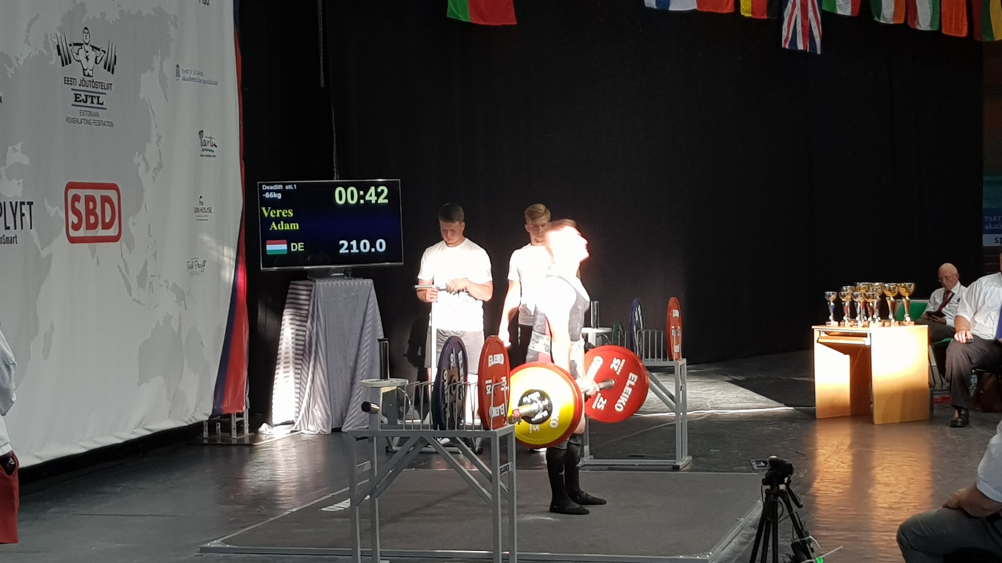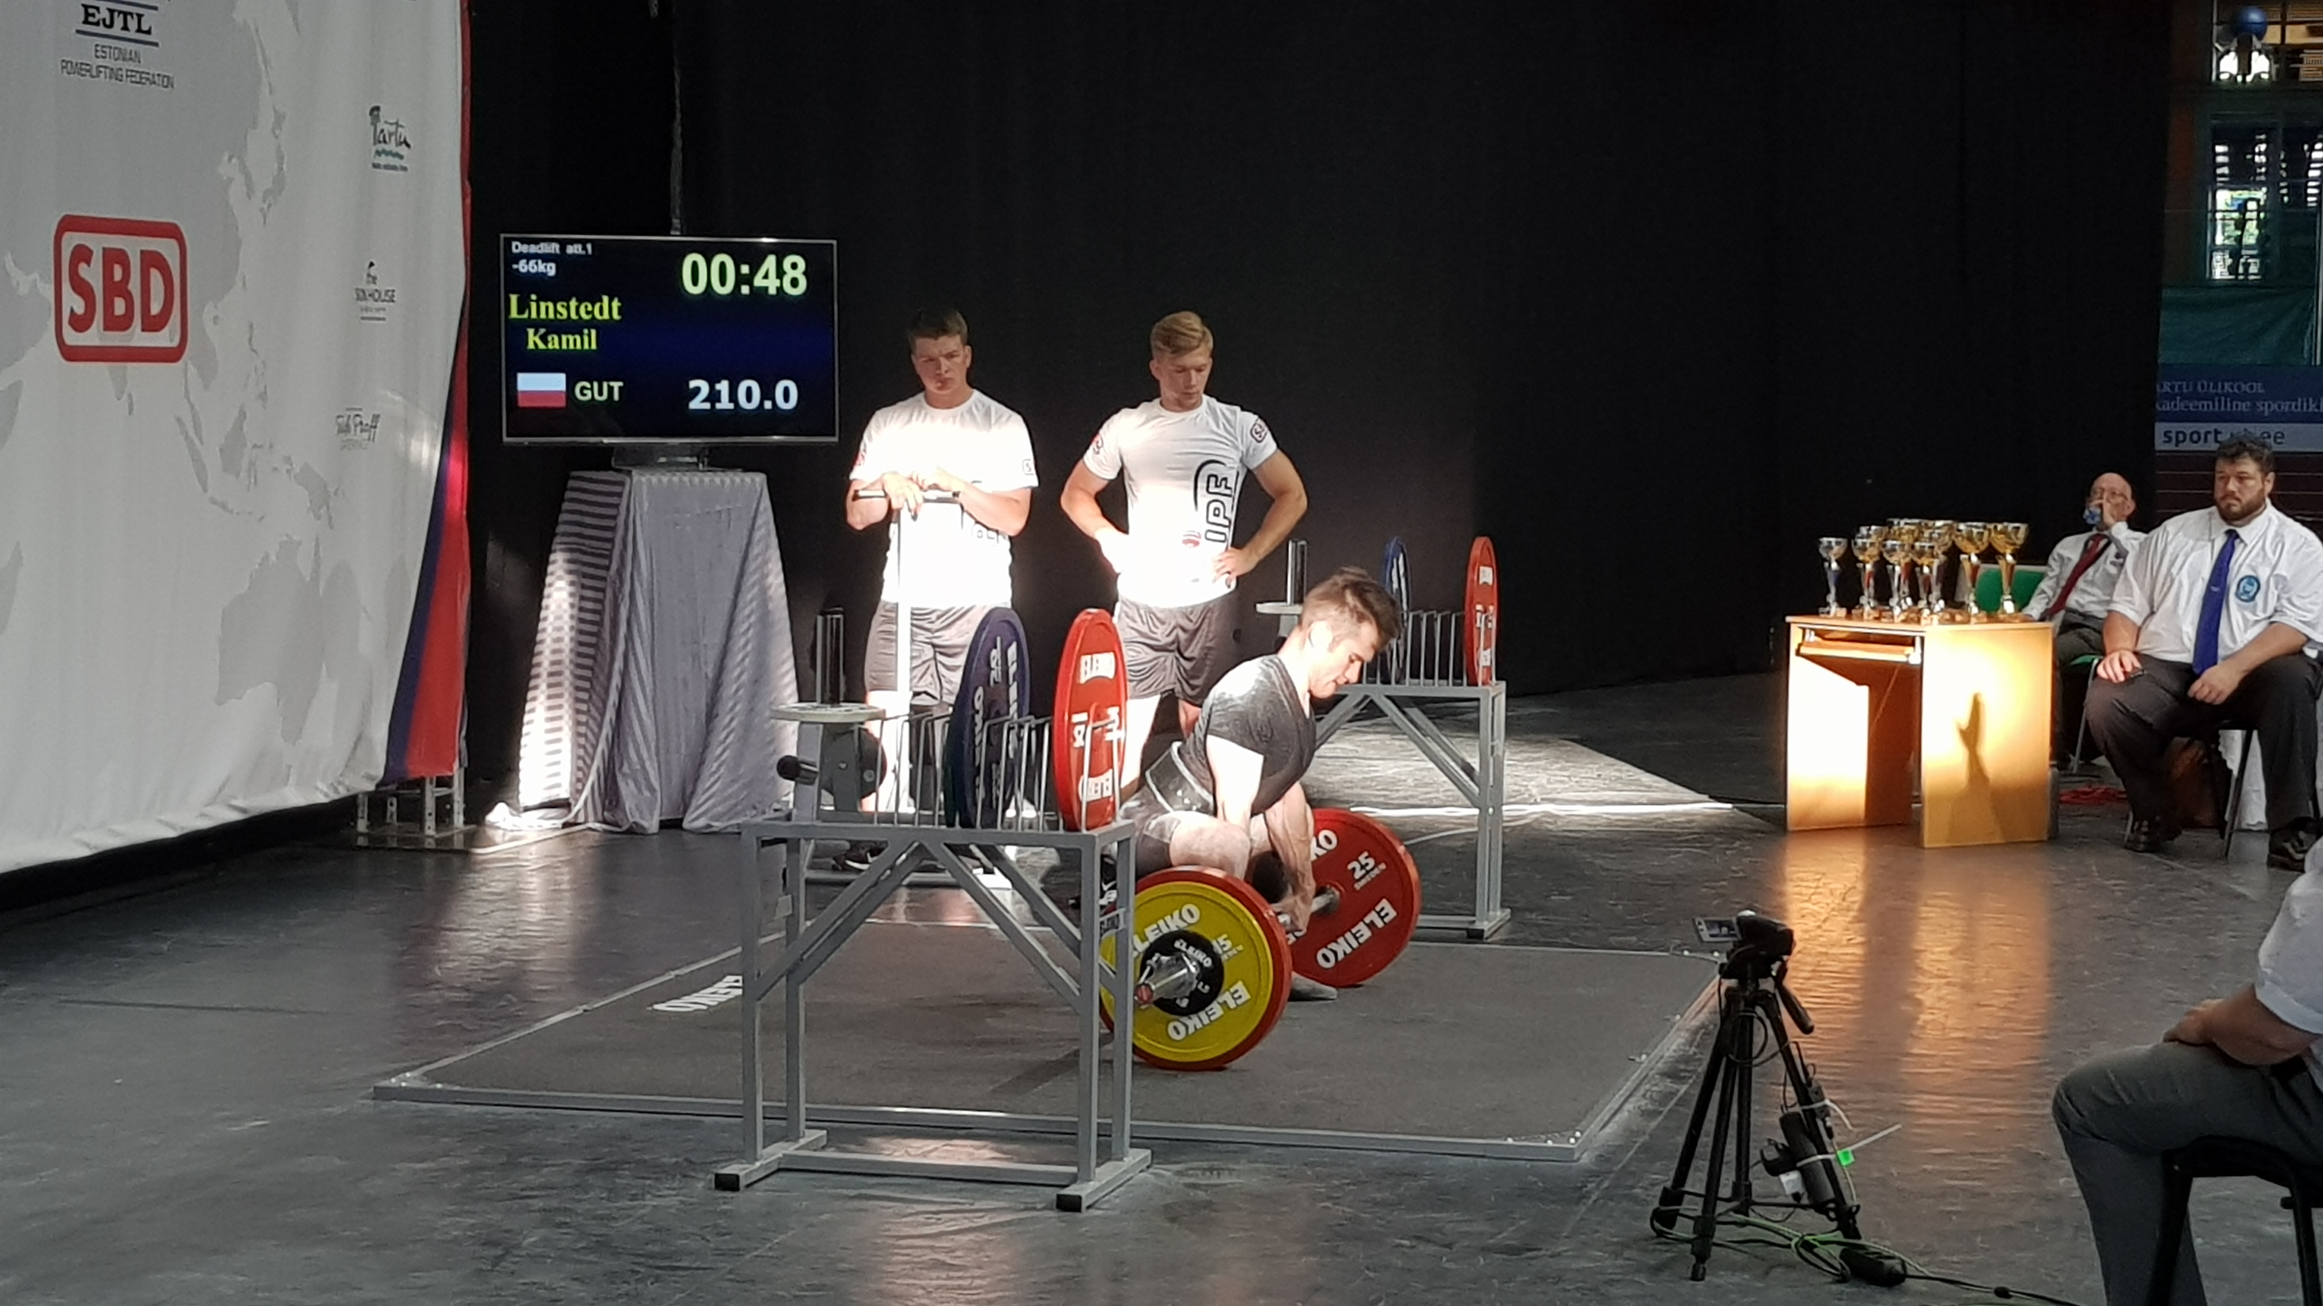
Light levels must remain constant throughout the event.

5.9 Insurance
The Promoter undertakes to obtain insurance coverage for the conduct of the Championships, such that the EPF and its office bearers are indemnified in respect of any claims for public liability, professional indemnity and/or negligence which may arise from the organization or conduct of the Championships.This includes insurance covering vandalism and theft of technical/electronic equipment provided by Organizer or EPF and used or stored in the competition hall during the championship.

Article 6 – Transportation

6.1 Arrivals Transportation
The Promoter shall provide transportation to and from the nearest airport to all the hotels used for the event. A reasonable cost may be charged for this service. There shall be no cost to EPF executive members and EPF approved technical officials.

Transportation need only be provided for those persons who have requested this service in writing and informed the promoter of their time of arrival.

6.2 Event Transportation
The Promoter shall provide transportation to and from the hotels used for the event and the event venue. The transportation shall run at times that ensure that all lifters and officials arrive in ample time for the weighing in and start of each weight class. It shall also run after each weight class back to the hotels.
There shall be no cost for this service for all accredited lifters and officials. All other persons using the service may be charged a reasonable cost.

Article 7 – Media and Sponsorship

7.1 Media Coverage
The Promoter must appoint a Media Officer latest 6 months prior to the event.
This Media Officer and the EPF Media shall together work to produce media material and press releases– according to the EPF Media Procedures - to ensure the event receives full media coverage.

7.1.1 Media Zone
The promoter must provide a media zone with tables, chairs, electric plugs, and internet connection, close to the main lifting platform with a clear view to take pictures and videos of the athletes for EPF Facebook, Twitter, Instagram and YouTube.

7.2 Television Rights
All television rights for European competition shall be the sole property of the EPF, less any fee negotiated with the promoting federation. If the EPF Executive cannot obtain a signed contract at least twelve months before the date of the competition, then the EPF will waive its rights in favor of the promoter and in accordance with the terms contained in the EPF By-Laws item 101.10.3.6, 103.4

7.3 Video Rights
103.11 of the EPF By-Laws provides as follows:
“Video fee: Any person making videos of European championships for commercial reasons, i.e. resale to the public at large, shall pay not less than EUR 200 for the privilege. The income to be shared equally between the Promoter and the EPF. The organizing national federation will however have the right to its own video coverage with the income to be shared as for commercial video with a copy for the EPF files. If no commercial contract for video exists, then individuals may be given permission to video separate bodyweight classes in which a member of their family or club is competing.”

7.4 Sponsorship
The Promoter or assignee shall have the right to arrange sponsorship for the event provided that such sponsorship is not incompatible with the image of the EPF and it does not contravene any contractual arrangement that the EPF may have entered into with any party. The Promoter or assignee cannot incur debts on behalf of the EPF, nor bind the EPF in any further contracts, without the EPF’s written agreement.

7.4.1 BANNER RULES for European Championship/Cup
The championship/cup logo must be in the hand of the EPF Secretary General latest 90 days
prior to the beginning of the championship/cup.
Remaining logos must be in the hand of the EPF Secretary General latest 28 days prior
to the beginning of the championship/cup.
All logos must be of a high quality and in vector graphic (EPS or AI Format)
7.5 Spotters T- Shirts and shorts.
At all European Championship/cup the spotters and loaders must wear T-Shirts and
shorts of the official EPF sponsors at all competition days...
The necessary number of T-shirts and shorts will be provided by EPF.
7.6 Event T-shirts.
Event (Championship) T-shirts with the official logo of the championship/cup are
produced and sold by the official EPF sponsor. The organizer is not permitted to
produce and sell their own. For this arrangement, the EPF compensates the organizer
the amount of 5€ for each lifter listed in the final nomination for the event.
The championship organizer must provide the championship logo to the EPF free of
charge and free to use (no restrictions) latest 90 days prior to the start of the
championship/cup.

7.7 Internet connection.
The Promoter shall provide internet connections in the Competition Hall to be able to set up internet streaming. The internet cable line must be fiber with capacity
1 internet cable line of minimum 20 MB upstream and 20 MB downstream
It is important that this line will not be shared with others! 1 internet cable line of minimum 1 MB upstream and 5 MB downstream. In case of wi-fi on the same line, Wi-Fi must be shut down or at least provided with a password just for the streaming team and EPF officials.
Both lines are to be dedicated to the championship only. EPF compensate the organizer with €400 for providing these the two lines and Wi-Fi

Article 8 - Championship Administration

8.1 Secretariat
The Promoter shall set up a secretariat in the official hotel, which shall be adequately manned for the duration of the event for at least eight hours daily. The purpose of the secretariat is to carry out the general administration for the championships, register the lifters and officials and provide information about the event to them. Where possible, Internet accessibility should be provided.

8.2 Information Package
Each national team shall be given an information package when it registers. The package must include the price list referred to in article 8.3 below.

8.3 Price List
The price list referred to in article 8.2 above must include information on the hotels used for the event and the rack rates (prevailing at the time of the event) for each of them shown in local currency and the approximate equivalent in EUR. The information on rack rates must be verified by each hotel under its letterhead. Other relevant prices such as the cost of tickets for the competition and the banquet should also be shown.

8.4 Photocopying
A good quality photocopier and an adequate supply of A4 size paper with a minimum weight of 80 g shall be situated in the secretariat or in the hospitality room for the use of the organizing committee and the EPF.

8.5 Payments
Payments for accommodation and other expenses may be collected when a team register. A receipt shall be issued immediately for each payment.
All expenses payable to the EPF, including the EUR 50 drug testing fee and the EUR 90 participation fee shall be collected by EPF. If any money is to be refunded to an individual or team this must be in the same currency in which the payment was originally tendered.

8.6 Form of Payments
It is preferable that the official hotel accepts payment by bank transfer, major credit cards or cash payments in EUR and other major European currency.
If guests cannot settle their accounts by credit card or major European currency this must be clearly stated in the original invitation to the event. Notice about the form of payment accepted by the hotel must be given. The EPF is not responsible for, and accepts no liability for, the payment of hotel bills.

Article 9 – Meeting Facilities

9.1 Meeting Room
The Promoter, at no cost to the EPF, shall arrange at the official hotel a meeting room for the use of the EPF. This shall contain a table and sufficient seating for up to ten people. The room shall be available on an “as required” basis and there shall be sufficient bottled drinking water and clean glasses for everyone attending a meeting.

9.2 Hospitality Room
At the championship or cup venue a room shall be designated exclusively for the use of the championship or cup referees and officials. The Promoter shall provide the working referees and officials free meals including a supply of bottled water, tea, coffee and light refreshments as described in By-Laws 105.3.5

9.3 Congress Venue and Technical Meeting Room
A room shall be provided for the Technical Meeting for the event and the annual EPF Congress (European Open Powerlifting Championships only). The room should be large enough to accommodate at least 60 people. A table that is large enough to seat seven people at, and on which there is at least one microphone for the use of the officials seated at the table, shall be placed at the front of the room facing the attendees for whom
at least one further microphone shall be provided. Projector, to be connected to a personal computer, and a screen must be available.

Article 10 – Championship Venue

10.1 Access
105.3 of the EPF By-Laws provides as follows:
At all European championships, the promoter shall provide free access to the venue and other competition buildings or functions for team officials and coaches on the following scale: 105.3.1 for the first competing lifters, three officials or coaches shall be permitted access.105.3.
For 2-3 athletes, 5 coaches or officials shall be permitted access and for 4 athletes or more, 6 coaches or officials shall be permitted which is the maximum number per competing group.
105.3.3 The courtesy of free access shall also be extended to all officiating referees and jury members. 105.3.4 The courtesy of free access shall be extended to all members of the Sports Medicine Team who participate during the championships. The names of such personnel shall be forwarded to the promoter and an agreement reached between the Doping Control Officer and the Promoter upon the number to be accepted.

10.2 Facilities
Promoters are referred to the EPF Organizing Checklist

10.4 EPF branded goods
The EPF, if required, will be allowed retail space free of charge in the designated area within the lifting venue for sale of EPF branded goods as well as space for displaying EPF logos or logos of co-operating partners.

10.5 Sponsor booths.
EPF has the right to set up sales booths of minimum 10 m² for each of the EPF sponsors
Maximum 5 sponsors) in the competition venue free of charge during the whole
Championship. The boots must be arranged by the Promoter in best possible positions related
To the venue and the audience.

Article 11 - Doping Control
11.1 Facilities
IPF will conduct the doping control and the Promoter must provide facilities as
Specified by the controlling organ.

Article 12 – Flags and National Anthems
12.1 Flags
105.2 of the EPF By-Laws:
“Each participating nation at a European championship must provide if required, a national flag approximately 1.5 m x 1.0 m in size. Any nation failing to meet this
Obligation will be fined the sum of EUR 30 to reimburse the promoter for any loss and inconvenience suffered. It is the responsibility of the promoter to issue a receipt on acceptance of the flag and request the return of this receipt on returning the flag to the team manager, If for any reason whatsoever, the promoter fails to return a nation’s flag, he shall be required to reimburse that nation for the loss suffered.”
The Promoter shall also reimburse for any damage to a flag. The promoter may provide the flags, and if so, this information must be stated in the invitation. The flags should be prominently displayed.

Article 13 – Awards and Participation Certificates

13.1 EPF Medals
The EPF standardized medals shall be used for the European Open Championships, and should preferably be used for all categories European Championships (By Laws 104.4).The face to be inscribed with the EPF-emblem and suitable wording. The reverse to remain blank for use by the promoter at his own expense. These shall be purchased from the EPF and presented for first, second and third places in each category based upon totals. Smaller, standardized medals to be presented for first, second and third places in the individual lifts of Squat, Bench Press and Deadlift in each category may be purchased from EPF or provided by the Sponsor. If medals are not ordered from the EPF Secretary General, the organizer must provide an example of the layout of the medals he will provide not later than 6 months before the championship to be inspected and accepted by the EPF Secretary General.

13.2 Ordering and Payment of Medals
The standardized medals for the overall medal winners and smaller medals for the individual lifts may be ordered from the EPF Secretary General no later than three months prior to the event and paid for prior to the commencement of the event.
If an organizer provides own medals, they shall be controlled and approved by EPF latest 3 months prior to the championship.

13.3 Participation Certificates
Participation certificate for each accredited lifter, coach, referee and official participating in the event will be posted on the EPF website under “Service” immediately after the championships

13.4 Best Team(s)
The Promoter shall provide trophies for the overall 3 best teams, Men and Women’s.

13.5 Best Lifter(s)
The promoter shall also provide trophies for the 3 best lifters, Men and Women’s, who produces the best performances based upon the IPF formula. (Optional for Master lifters)

13.6 Award Ceremony.
The award ceremony will take place at the completion of each category as described in the EPF Organizing Handbook. The Promoter may at its own expense, provide memory awards for all lifters taking part.

Article 14 - Farewell Banquet

14.1 Farewell Banquet
The Promoter shall host an official farewell banquet at a venue that is large enough to accommodate all the lifters, officials, guests and supporters who wish to attend. There shall be sufficient food for all persons attending the function.
The designated EPF officials shall be guests of the Promoter. For all other persons the Promoter may impose a reasonable charge for admission to the banquet.

Article 15 – Financial Obligations

15.1 Settling Outstanding Accounts
The Promoter is required to settle all its outstanding accounts with the EPF before the championship or the cup commences. This includes (but is not limited to) outstanding affiliation fees, any outstanding sanction fee or part thereof (including interest for late payment) and the cost of the championship medals (and ribbons) if these have been ordered from the EPF. If for any reason the promoter is unable to settle these amounts in full (e.g. it may be relying on income from the event) a suitable arrangement must be reached with the EPF before the championships or the cup commence.
Settling of EPF accounts must be in Euros.

15.2 Participation and Drug Testing fees
The drug testing fees are the property of the EPF.
The participation fees will be shared between the EPF and the Promoter of this European Championship in the following rate: EPF will receive 2/3 and the Promoter 1/3 of the participation fees collected by EPF for this Championship.

15.3 Medical staff.
During the competition days, the organizer must provide medical support
staff (First Aid)

15.4 Scales
A scale equal with the one at the weighing in MUST be placed at the official competition hotel
at least one day prior to start of the competition.

THE PROMOTER ACKNOWLEDGES THAT IT HAS READ AND CLEARLY UNDERSTANDS ITS OBLIGATIONS UNDER THIS CONTRACT.

BY SIGNING THIS CONTRACT, THE PROMOTER AGREES TO BE FULLY BOUND BY ITS TERMS AND CONDITIONS REGARDING:

Name of the championship:
Name of the National Federation:
Year of organizing:

Authorized signatory for and behalf of Promoter | Place | Date
Print Name

Authorized signatory for and behalf of EPF | Place | Date
Ralph Farquharson EPF Secretary General
Print Name

