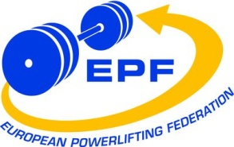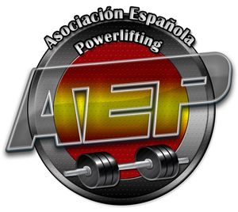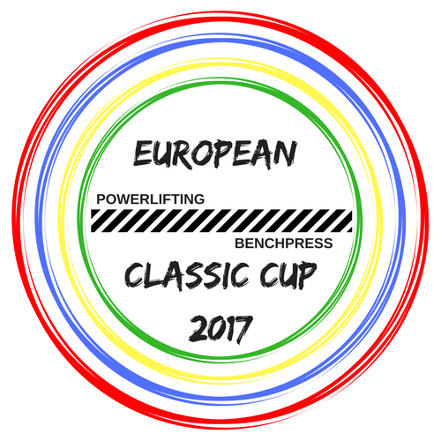NOMINATION FORM
PRELIMINARY: Extended  until 15th October 2017 | FINAL:  10th November 2017 | Last day to cancel the booked hotel rooms:  16th November 2017

The European Powerlifting Federation and the Spanish Powerlifting Association invite for the
3rd European Open Classic Powerlifting Cup, men & women
3rd European Open Classic Bench Press Cup, men & women
Alhaurín de la Torre (Málaga) -SPAIN-, 1st - 3rd December 2017
THE NOMINATION FORM MUST BE SENT TO:
Original: Meet Director, Francisco Gutiérrez, Jarapalos 14 (gym) , 29130 Alhaurín de la Torre, Málaga, Spain
Mobile: +34 650 644 069, e-mail: MalagaPowerChamp@gmail.com
Copy: EPF Secretary G., Ralph Farquharson, Galena 5, Casa 44, Villapiedra, 03189 Orihuela Costa, Alicante, Spain
Phone: +34 966 733 367, Mobile: +34 650 041 559, e-mail: ralph@europowerlifting.org
(Please, use for each person his surname and whole first name, not only first type of the name or nicknames!!!)
Submitted by |  | National Powerlifting Federation/Association

Submitting officer: |  | Title: |  | Date:

Teammanager : |  | Head Coach:
REFEREES NOMINATION:
Each referee must state which championship and group he/she will be free from other duties (coach, lifter, ...) in column “Available for categories”. If available categories are not stated, he/she may be nominated for both championships in all the categories.
It is an obligation of every Federation to confirm the participation of all their Referees nominated in the Final Nomination or cancel the Referees who will not participate in the Championships !!!
Deadline for changes of categories for which has been allocated must be made latest 7 days prior to the Technical Meeting of the competition. If referees do not indicate changes during that time, referees are obliged to be available for the original categories stated.

Referee 1 : |  | Cat : |  | Available for categories:

Referee 2: |  | Cat: |  | Available for categories:

Referee 3 : |  | Cat : |  | Available for categories:

Referee 4: |  | Cat: | 1 | Available for categories: | Only for Jury in case of insufficient # of Cat. 1
CONTACT ADDRESS: obligatory to fill in
Name: |  | Street: |  |  | Zipcode:
City: |  | Country: |  | Phone:
Fax: |  | E-mail:

NOMINATIONS:
The number of lifters allowed in each day & in each body weigh category is limited. So, it's important to send your nominations as soon as possible in order to guaranty your participation in these championships

3rd European Open Classic Bench Press Cup, men & women
M/W | FAMILY NAME | FIRST NAME | BIRTHDAY | BODY WEIGH | BP

3rd European Open Classic Powerlifting Cup, men & women
M/W | FAMILY NAME | FIRST NAME | BIRTHDAY | BODY WEIGH | SQ | BP | DL | TOTAL

REGISTRATION OF OTHER TEAM MEMBERS:
(team leader, assistant coach, doctor, physiotherapist, assistant, delegate, etc.)
FAMILY NAME | FIRST NAME | DUTY

Visa Support Form

SPANISH POWERLIFTING ASSOCIATION

Name of the official: Eduardo Prada

Phone:+34-695 35 81 46, e-mail: secretarioaep@gmail.com
Full names of athletes | Birth Day | Passport Number | Expiration Date

Full names of coaches | Birth Day | Passport Number | Expiration Date

